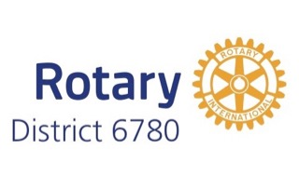 | District Grant Checklist  2024-2025 | 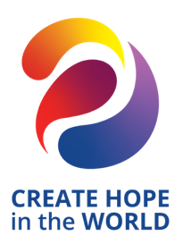

Are all your district grant and global grant reports up to date? Last year’s District Grants must be completed, and the final report accepted before funding is awarded for a new project.

Is your club grant qualified for Rotary Year 2024-2025?
- Have as least two club members attended qualification training during Rotary Year 2023-2024?
- Has your Club Qualification Memorandum of Understanding and Club Qualification Plan been submitted to the District Grant Committee (may be submitted with the DG application)?

Has a second person in your club read the grant carefully to ensure that it reads well and answers each of the questions in the application?

Is the project timeline consistent with the District Grants timeline? (April 1, 2024 – March 31, 2025)

Does the project description clearly state how the project will assist those in need?

Will Rotarians be actively involved in the project? Do these Rotarians know how they will be involved?

Have your club members considered how the benefits of this project can be sustained in the future?

Has the project chairperson been identified? Is this individual correctly listed on the application with complete contact information? Is this individual responsible for completion of the project, preparation of the progress and final reports and collection of receipts?

Is a detailed, itemized budget included in the application?

Do all the expenses budgeted to be paid by grant funds comply with the grant restrictions?

Are all partner contributions listed in the application? Do the contributions match the budget?

Has the Club President or President-Elect signed the application? Do they understand their responsibilities on this grant?

If a cooperating organization is involved, is there a letter included with the application agreeing to cooperate with any financial review of the project?

Have the partners made copies of all documents for their files prior to submitting them to the District Grant Committee?

